Kol simcha torah gazette
For parshas behar 5784
Volume 8 Issue 35 (Whole #395) 17 Iyar 5784/ May 25, 2024
Printed L’illuy nishmas Nechama bas R’ Noach, a”h

For a free subscription, please forward your request to keren18@juno.com
Past emails can be found on the website ShabbosStories.com under Brooklyn Torah Gazette

The Importance of “Faithfully” Observing
the Shemittah Laws

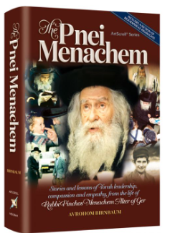

This parashah opens: “Hashem spoke to Moshe on Har Sinai, saying, ‘. . . When you come into the land that I give to you, the land shall observe a Sabbath rest for Hashem. For six years you shall sow your field . . .’”
Chazal (quoted by Rashi) ask: Why does the Torah mention that the laws of shemittah were given at Sinai? To teach that just as every detail of shemittah’s laws was given at Sinai, so every detail of the Torah was given at Sinai.
R’ Pinchas Menachem Alter z”l (1926-1996; Gerrer Rebbe) observed that Sinai is mentioned in connection with other mitzvot too. Why, then, is this lesson taught here of all places?
The Gemara (Sanhedrin 39a) asks: What is the reason for shemittah? It answers: “The Torah says, ‘Plant for six years and rest in the seventh year, so that you will know that the land is Mine’.”
It appears from here, says the Gerrer Rebbe, that planting during the six years also is a mitzvah, provided that it is done with the same faith in Hashem with which one rests in the seventh year. (This is why, says the Rebbe’s grandfather, the Sefat Emet, the consequence of not keeping the shemittah is exile.
If we lack the faith in G-d to keep the shemittah, then we also will not plant with faith. In that case, we have no business being on the Land.) The whole world was created so that we can keep the Torah; when we observe the Torah, we testify that Hashem created the world. We bear the same testimony when we live a life which is imbued with the message of shemittah. This is why it is appropriate to compare the entire Torah to shemittah, as in the Rashi quoted above. (Pnei Menachem)

Among other Mitzvahs, this week’s Parsha discusses the Mitzvah of Tzadaka.The Gemarah in Bava Basra tells us that one who doesn’t give Tzadaka is equivalent to one who worships idols.
Why? What is the connection between Tzadaka and idol worship. A person who worships idols does so for only one reason - he thinks that the idol is a god and has the ability to help him - do things for him - control good and evil.
A person who refrains from giving Tzadaka is acting that way for the same reason. He believes that there is power in money to do things for him - it controls good and bad. In reality it is the exact opposite - it is giving Tzadaka, not accumulating wealth that protects a person. (Rabbi Elchonon Wasserman)

Do not harass one another, and you shall fear G-d. (25:17) From the fact that Hashem attaches His Name to the admonition regarding verbal harassment, Chazal derive that verbal harassment is a greater sin than monetary harassment. The Baalei Mussar explain that cheating an individual out of his money has a limit; we know the extent of the damage. Hurting someone with words has no limit. Hashem knows how deep and painful is the hurt caused by words. (Vignettes on the Parsha)

Reprinted from the Parashat Behar 5784 email of R’ Yedidye Hirtenfeld’s whY I Matter parsha sheet for the Young Israel of Midwood in Brooklyn, NY.
Rav Avigdor Miller on
Why When Jews Acquire
Money, They Become Less Frum

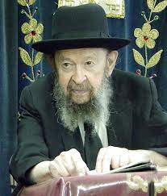

Now this is something that’s a well-known phenomenon. It’s constantly reiterated in the Scriptures, in the Tanach.– The righteous nation became fat and began kicking.
It’s like a cow. A cow, if you don’t feed it too much, it’s docile. But once you give it too much food, then if you come to milk it, it’ll give you a kick in the face.
And that’s how children are too, by the way. They’re overfed today with too much candy and ice cream. And that’s why they’re so fresh. If they had to go to work in order to support themselves, then you’d see it would be a much more decent population.
Money is a great test.
Now, for good people money is a glorious opportunity. They become more grateful to Hashem and they utilize their wealth for the support of the Torah causes. And they become like Rabbi Akiva or like Raban Gamliel or like Rabbi Tarfon or like Rabbi Elazar ben Azarya, all the great people of our history who knew how to live with money.
But those who are not trained, those who are not prepared for wealth, are ruined by wealth. Like Shlomo HaMelech said:– Don’t give me extreme wealth or extreme poverty, – Give me just enough.
And therefore, it’s a great test and very many people have stumbled and have fallen because of this test.

Reprinted from the Emor 5784 email of Toras Avigdor, based on the teachings of Rav Avigdor Miller, zt”l. Adapted from Tape #400 (March 1982).
The Connection of the Sabbatical and Jubilee Years to the
Spiritual Service of the Jew
From the Teachings of the Lubavitcher Rebbe
Rabbi Menachem Mendel Schneerson, Zt”l
Adapted by Rabbi Eli Touger
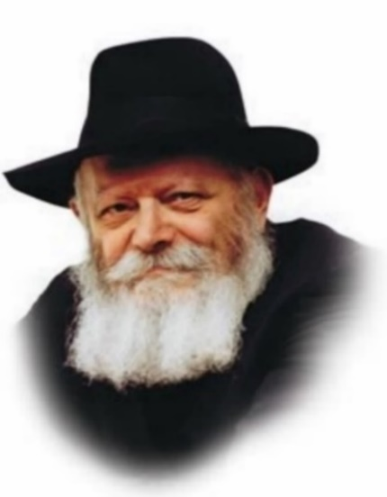

This week we read the Torah portion of Behar. Behar contains the commandments of the Sabbatical and Jubilee years: "Count for yourself seven Sabbaths of years, seven years seven times...and you shall sanctify the fiftieth year." Every seventh year is a Sabbatical year; the fiftieth is a Jubilee. Then the cycle begins anew.
Concerning the Jubilee year the Torah states, "Proclaim liberty throughout the land for all its inhabitants." According to the Talmud, this means that there can only be a Jubilee year "when all its inhabitants" are living in the land. Thus, "When the tribes of Reuven and Gad and half of Menashe were exiled, the Jubilee was abolished."
Nonetheless, the Talmud relates that in the times of the Second Holy Temple the fiftieth year was still officially sanctified, even though the mitzva of the Jubilee was no longer in effect. This was done to maintain the same cycle as before, i.e., with the counting commencing again in the fifty-first year.
After the Second Temple was destroyed (and during the Babylonian exile), the fiftieth year ceased to be sanctified. The cycle of counting Sabbatical years began on the fiftieth year itself.

The Three Ways of Relating
To the Jubilee Year
Thus, there have been three ways of relating to the Jubilee.
Chasidic philosophy explains that the Sabbatical and Jubilee years are symbolic of spiritual levels in a Jew's service of G-d:
The Sabbatical year relates to the negation of the sense of self. The person perceives himself as an individual, yet willingly nullifies himself before G-d.
The Jubilee year relates to a higher level, of freedom from all limitations, a level that will be fully realized in the Messianic era.
This also explains why the Sabbatical year applies today (by Rabbinic decree), whereas the mitzva of the Jubilee was only fully observed during the First Temple period. The very highest level of spirituality could only be attained at a time when the Divine Presence was manifested in the world so strongly.

Counted and Sanctified
But Not Observed
The Second Temple period was somewhere in the middle. G-dly revelation illuminated the world, but in a less obvious manner. The Jubilee was therefore counted and sanctified but not observed.
The lowest level occurred after the Destruction, when it was no longer possible to even comprehend the intense spirituality of the Jubilee and it ceased to be counted.
Today, our service consists of "only" accepting the yoke of heaven and nullifying the ego, but in a sense this gives us the greatest advantage, as it enables us to access the soul's essence. It also helps us prepare for the Sabbatical of the Messianic era, may it commence at once.

Reprinted from Behar-Bechukosai 5761/2001edition of L’Chaim, a weekly publication of the Lubavitch Youth Organization in Brooklyn, NY. Adapted from Volume 7 of Likutei Sichot.

Rabbi Berel Wein on
Parshat B’Har 5784

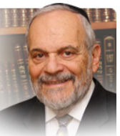

The parsha begins with the word that defines its name – b’har – on the mountain. The mountain naturally is Sinai and the Torah’s emphasis is to reinforce Judaism’s core belief that our Torah is G-d-given and not the work of a committee over centuries. This basic belief lies at the heart of many of the contentious disputes that have marked Jewish life over the ages.

While original splinter groups, such as the Saducees and the Karaites, did not openly deny the validity of the Written Torah as being godly in origin, they strenuously denied the holiness of the Oral Law of Sinai and denigrated its rabbinic interpretations and decrees. This led to serious splits within the Jewish people and to bitter recriminations that lasted centuries. In all these instances, the divinity of Torah and of its Oral Law always eventually won out. Deviant movements eventually fell away from the main body of the Jewish people, both individually and as a potent group in influencing Jewish life and mores.

The “mountain” referred to is the one at Sinai where the Torah was given to Israel. It is a difficult mountain to ascend, The Psalmist asks: “Who can ascend the mountain of G-d?” But as difficult as it is to ascend the mountain, it is even more difficult to remain there. The Psalmist again intones “who can maintain oneself, in the holiness of G-d’s place?” The struggle about maintaining the Jewish people on the mountain of G-d in belief and faith has been the hallmark of Jewish life over millennia. It has not abated in our time.

Jewish secularism comes in two different and divergent forms. One is simply that the Torah’s way of life and value system does not harmonize with modern society and its demands. Shabat, kashrut, etc. are all too restrictive to be functional in today’s world. The Jewish people cannot afford to be so different from the rest of the world. The mountain may have had its purpose at one time, but that time has now passed. New ideologies and circumstances have rendered it obsolete. So, for them the mountain no longer exists.

A second group denies the existence of the mountain altogether. There never was a mountain – it is all an urban legend fostered by the rabbis over the ages. In effect, our grandfathers were all liars or naïve believers in legends and stories for which there is no current historical scientific evidence. Aside from these two groupings there are groups who wish to be included in the religion of Judaism and who do not see themselves as being secular. But, in varying degrees, they follow the ideas of the Saducees and the Karaites though they essentially also deny that the mountain has anything to do with G-d and divine origins.

History shows that in the long run such philosophies and movements give way to the pressures of time and circumstance and eventually lose their influence and power. At the end of the day, only the mountain remains as it always has, challenging us to ascend it and maintain ourselves upon it.

Shabbat shalom.
Reprinted from the current website of rabbiwein.com

How to Think About Hashem When Doing Business

And when you sell anything to your fellow man or buy from your fellow man, you shall not cheat one another". If one remains aware that Hashem is the creator of all people, he/she will be careful not to deceive others (just as one would be most careful if dealing with the offspring of an emperor).
Rav Nachman was asked how it is possible to think of Hashem when involved in business, to which he replied "people find it easy to think about business when they are praying; similarly, if one really wants to, he/she can think of Hashem while engaged in business."(Growth Through Torah by Rabbi Zelig Pliskin)
Nas Daily Tackles Judaism
By Dov Ber Cohen

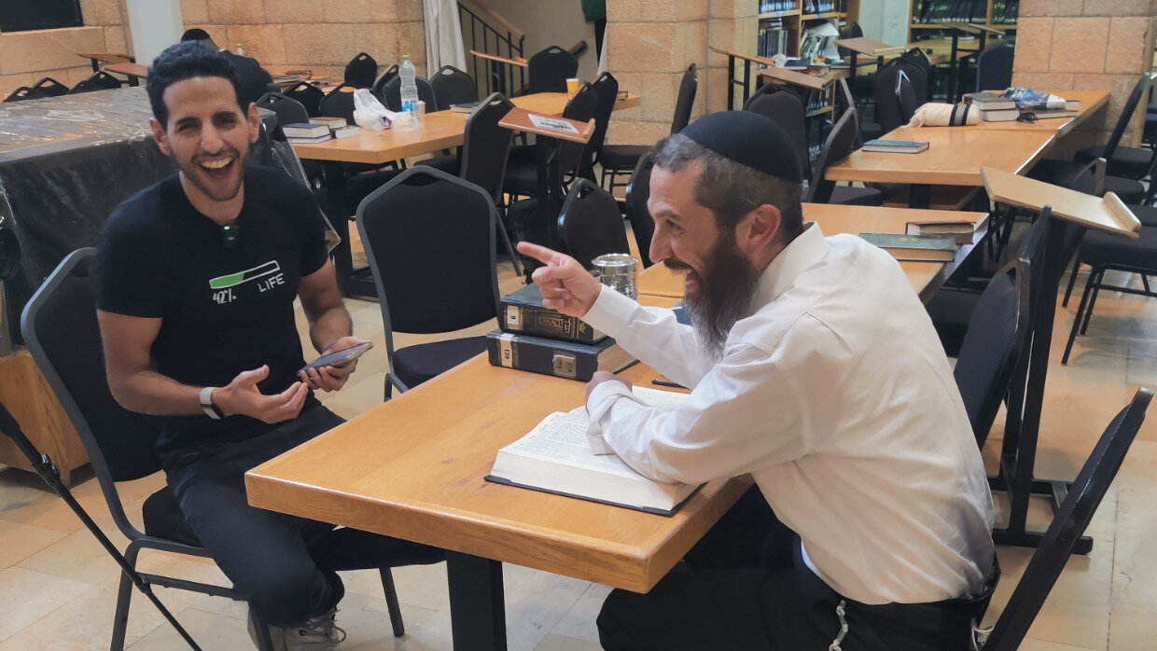
Here are the two big takeaways about Judaism that didn’t make the Nas Daily video
.
“Dov Ber, your Passover vacation is going to be different this year.”
I got word that I will be having the opportunity to learn with Nuseir Yassin, the huge media influencer who creates Nas Daily. The “Israeli-Palestinian” has 22 million Facebook followers, 13.4 million subscribers to his Youtube channel and 4.4 million followers on Instagram.
“He’s doing a 6-month series on world religions. He’s already done Buddhism, Hinduism, and Atheism and he’s coming to Aish to learn about Judaism. He’d like to speak to a Rabbi and you are the man.”
Essentially, I’d be sharing a lengthy conversation about Judaism with the entire world. What message should I give? Nuseir seemed to be a genuine guy trying to share meaningful content with the world. I looked forward to meeting him in person and wasn’t disappointed. He is down to earth, humble, inquisitive, open, and genuine.
Nuseir told me that he wanted to focus on two aspects of Judaism – community and our practice of chavruta-style learning where pairs debate and discuss Judaism’s holy texts to arrive at the deeper truth.
Although those two ideas are certainly part of the Jewish lifestyle, they barely scratch the surface of Judaism’s profound teachings that fueled my own spiritual journey from the Far East to living in Israel.
During our time together, we discussed life, Judaism, and world peace. I managed to share some of the paradigm-shifting teachings that were so meaningful to me but most didn’t make the final cut of the video, Here are two empowering and inspiring ideas that I think the world should know about Judaism.

G-d and the Purpose of Life
Some people think G-d is an angry man in the sky with a bunch of rules that you have to follow to make Him happy and if you don’t you’ll be punished. Rabbi Kook, the first Chief Rabbi of Israel, said that that idea of G-d is itself idol worship. G-d isn’t some entity that we have to please and appease.
Abraham lived in a time when people worshipped the sun, stars, trees, and even man-made stone idols – physical, unconscious, limited entities. Abraham looked around him, at the beauty, harmony, design, and complexity of life, even at his own consciousness, and realized there must be an Infinite Consciousness, an Intelligent Creator of the whole system.
Infinite Consciousness permeates and enlivens the whole of our reality and also stretches infinitely out beyond time and space. This philosophy is not just the belief that there is One G-d (Monotheism), but Panentheism – the belief that One Infinite God is at the same time giving existence to, saturating, and sustaining finite reality, while not being limited to it (not to be confused with pantheism, which teaches the universe is G-d).
The universe therefore is a finite projection of Infinite Consciousness (something that quantum physics is coming to prove - see the amazing work of Professor Don Hoffman) and we, our souls, are finite conscious expressions of Infinite Consciousness. That’s mind-blowing!
So, why did Infinite Consciousness create anything in the first place? This Infinite Being doesn’t need to create; it isn’t lacking and it doesn’t get bored or lonely.
Therefore, creation wasn’t for the Creator; it was for the creation. Creation was an act of giving, an act of pure love.
A loving parent wants their child to be fulfilled, to joyfully reach their potential, to grow, achieve, and create for themselves. So too, Infinite Consciousness created a world in which we could use our free will to improve ourselves and improve the world or do the opposite. By manifesting goodness, overcoming the evil within ourselves, and doing the same in the world around us, we can truly experience the joy of living a meaningful life.

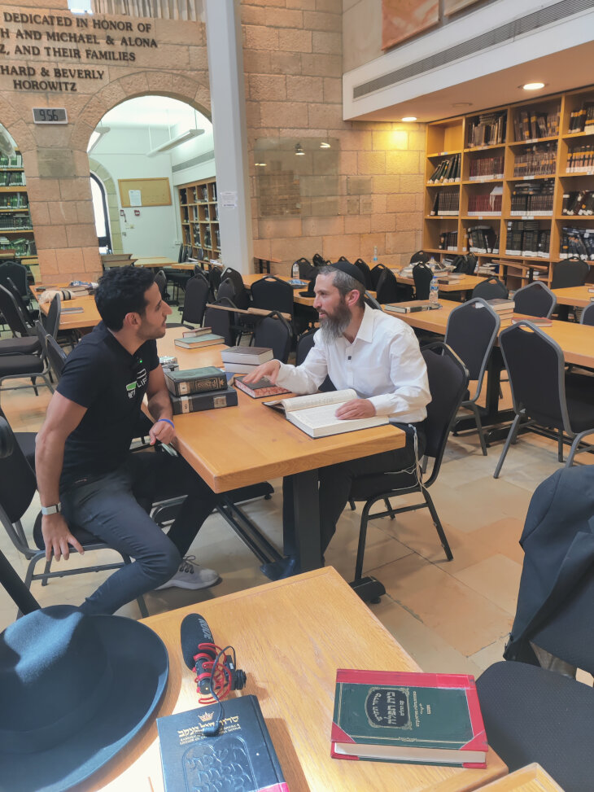
Learning with Nuseir at Aish

A profound story is told of the Roman General Turnus Rufus and Rabbi Akiva. The Roman, who was against circumcision, asked Rabbi Akiva, “What is greater, the work of G-d or the work of man?” He was implying that G-d created our bodies in one way, we shouldn’t change that through circumcision. Rabbi Akiva asked in reply, “Well what would you rather eat, wheat or bread?” Wheat is the work of G-d, bread is the work of partnership between G-d and man. That’s the highest level. It makes life meaningful and pleasurable.
Far from being evil sinners trying to appease the man in the sky, we are partners with G-d in the perfection of the universe. What G-d wants from us is to partner with Him in perfecting ourselves and the world around us, and in this way, we get what G-d wants for us - the immense pleasure of self-actualization and a relationship with Him.
More than G-d wants us to be with Him, God wants us to be like Him. To perfect ourselves on a physical, emotional, and spiritual level, to be conscious creators of goodness in the world, and thereby build our relationship with Him.

Balance Physical and Spiritual
When I was living in Asia for six years, immersing myself in the culture and spiritual practices, I found that Eastern spirituality in general involves detachment from the physical world. Buddhist monks don’t get married, don’t have money, don't eat after 12:00 p.m. I did an almost complete fast for seven days, just two cups of water a day, a small piece of papaya on three days, and half an apple one day when I decided to climb two hours up the mountain to meet the Dalai Lama. The world I grew up in the West was the opposite it was focused on mega-consumerism: sex, money, food, and social media.
Jewish spirituality teaches that we need to find balance. We can have physical intimacy, just with the right person, in the right way, at the right time, and with the right intention. If done in this way, not only is it okay, it is a vehicle to reach a high level of spirituality and holiness.
We can enjoy good food, we just make sure it is kosher, we say a blessing before we eat, eat consciously and in moderation, and then say a blessing afterward. In this way, eating itself becomes a spiritual act.
We can be rich, we just shouldn’t get our sense of self or happiness from our wealth. We give at least 10% of our income to charity, and we use it for healthy things and to create goodness in the world.

G-d Wants Us to Enjoy the Pleasures of This World
G-d wants us to enjoy the pleasures of this world. The first thing G-d said to Adam and Eve in the Garden of Eden was “Eat from all the trees in the garden (apart from that one).” We have taste buds and there are over 2000 types of fruit! Clearly, the Creator wants us to enjoy the physical pleasures of the world. However, physical pleasure just for selfish, short-term pleasure-taking is missing the point and will never create happiness, self-respect, or spirituality.
The purpose of pleasure is connection. The pleasure, physical, intellectual, and spiritual, that people give each other is what connects them on an emotional level. So too the pleasure we take from the world is supposed to connect us, through gratitude and awe, to the provider of the pleasure – G-d.
Judaism is about relationships. Our relationship with ourselves, with our fellow humans, and with G-d. Pleasure, used in the right way, is the glue that creates a close relationship. So, we can have the best of all worlds and enjoy life on all levels.
There are so many life-changing ideas in Judaism; it’s impossible to reduce them to one article or a short video, even a Nas Daily video. My hope is that people will get a taste and want to learn more to empower your journey to purpose, happiness, and meaning in life.

Reprinted from the current website of aish.com
10 Facts You Should
Know About Masada
By Yehuda Altein

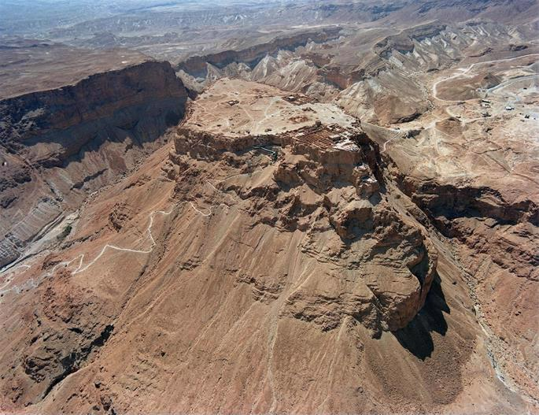
A aerial view of the Masada fortress above the Dead Sea. Photo courtesy Mosher Milner
Masada, an ancient fortress atop a high plateau in the Judean Desert, was the site of the last remaining stronghold of Jewish forces during their 1st-century revolt against the Romans. Masada is currently one of the most popular tourist attractions in Israel. Read on for 10 facts about this iconic historical landmark.

1. It Rises 1,300 Feet Above the Desert Floor
The ruins of the Masada fortress are located atop a mesa, a flat-topped rock elevation rising abruptly from the desert floor. Located at the eastern edge of the Judean Desert near the Dead Sea, the site’s remote location and difficult accessibility made it an ideal spot for a fortress.

2. Herod Built Palaces and Cisterns
In the 1st century BCE, King Herod, a former slave who governed Judea under Roman patronage, built an elaborate fortress on this mountaintop, including spacious palaces, luxurious bathhouses, well-stocked storerooms, and 12 enormous cisterns. With water a scarcity in the desert, Herod built an elaborate network of aqueducts to carry every drop of rainwater from the nearby wadis to the Masada cisterns.

3. It Was Occupied by Jewish Rebels
In 66 CE, Jews throughout Judea revolted against Roman rule. A group of zealots (whose approach was not necessarily in line with that of the rabbis) led by Elazar ben Yair took refuge in Masada, where they found Herod’s structures and storehouses intact. Following the Roman conquest of Jerusalem and the destruction of the Second Temple three years later (69 CE), more Jews joined the group. Sustained by the extensive stores of food and water and protected by the impassable slopes, the rebels used Masada as a base for raids against the Romans (as well as competing Jewish factions).

4. The Romans Laid Siege
In 72 CE, the Roman governor decided to destroy this final outpost of Jewish resistance. Gathering an army of 15,000, among whom were many Jewish prisoners of war, he laid siege to the fortress and attempted to breach its walls. After failing to breach the eastern wall, the Romans built a long ramp on the western side upon which a battering ram was hoisted. The battering ram succeeded in breaking the stone wall, and the zealots realized their end was near.

5. The Rebels Chose Suicide Over Slavery
The night before the Romans penetrated the compound, Elazar gathered the zealots and gave an impassioned speech, exhorting them to take their own lives rather than submit to Roman slavery. Each man proceeded to kill his wife and children, after which the men drew lots and killed each other. Of the 967 individuals residing in Masada, the only survivors were two women and five children who survived the mass suicide by hiding in a cistern.

6. Info on Masada Comes From Josephus
The historical information we have about Masada comes from controversial Jewish historian Josephus Flavius.¹ During the Jewish revolt against the Romans, Josephus commanded the Galilean forces. Captured by the Romans in 67 CE, he settled in Rome where he set out to chronicle the details of the unsuccessful revolt. Although the accuracy of his Masada account is the subject of debate by contemporary historians, the general outline has been corroborated by archaeological discoveries.

7. It Was Rediscovered in the 19th Century
The site of Masada was discovered by Edward Robinson and Eli Smith in 1838. Many excavations have since been conducted, uncovering most of Masada’s structures and thousands of well-preserved artifacts. The camps, fortifications, and assault ramp at its base constitute the best-preserved Roman siege system in the world.

8. It Showcases Jewish Life
Among the more fascinating discoveries made at Masada are two mikvahs that have been found to perfectly meet all halachic standards, as well as one of the oldest synagogues ever to be unearthed.

9. It Is a World-Famous Attraction
Masada ranks as one of the most famous tourist attractions in the Holy Land, drawing hundreds of thousands of visitors every year from across the globe. Guests can access the fortress by cable car or by climbing the mountain on foot, typically using either the winding Snake Pathway on the east or the Roman-built ramp on the west. However you get there, a trip to Masada is sure to be an educational experience that will leave you both inspired and perspired. (You’re in a desert after all.)

10. It Is a Symbol of Jewish Heroism and Eternity
As important as the Masada events are in Jewish history, it is important to remember that Jewish law forbids taking one’s own life. Some rabbinic opinions hold that suicide to avoid being tortured into sinning is allowed and perhaps even meritorious,² but killing oneself to avoid slavery is more problematic.
The morality of their decision notwithstanding, Masada tells a tale of heroism in the darkest moments of our history, when the future of Judaism seemed bleak and hopeless. The fact that its sites are visited by thousands of proud Jews each year tells the story of Jewish perpetuity.
Although the zealots believed Jewish life in the Holy Land was all but over, history has proven them wrong: the Jewish nation is alive and well, both in Israel and the Diaspora, and will continue to endure for eternity.

Reprinted from the current website of Chabad.Org

